**Project 2: Blog Application**

Blog application with Django that allows users to create, edit, and delete posts. The homepage will list all blog posts, and there will be a dedicated detail page for each individual post.

**Requirements:**

* Python 3.7 or above
* Django Framework
* VS Code
* Web Browser (Chrome)

**Create & Activating Virtual Environment for Django:**

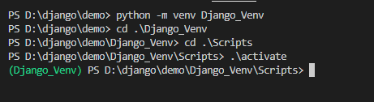

**To Create a New Project:** Blog_App

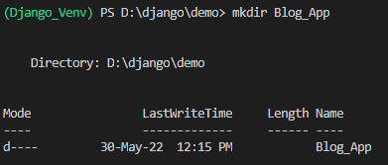



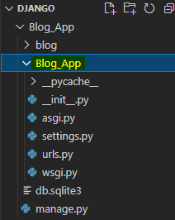 //Project Created Successfully



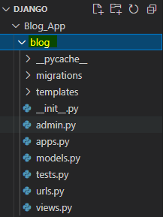

Created name should be given in setting.py

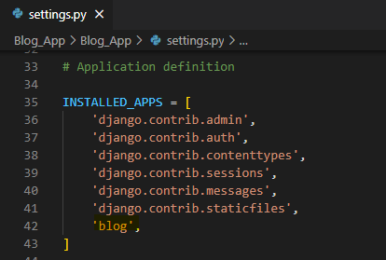

Need to create below file for separate in application folder

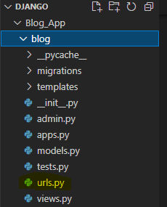

Need to create folder for template with templates name in application folder

Import os and assign the template like below in settings.py

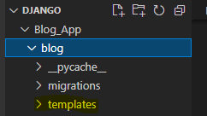

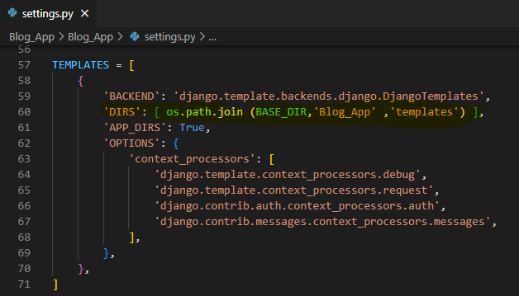

**To Migrations:**



It will create a file like below

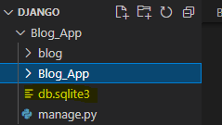

Now we are done with the database.

Creating Admin Login for Blog_App:

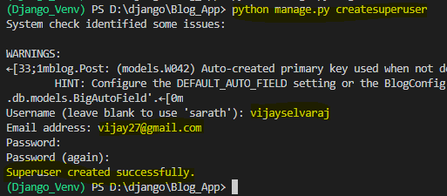

To Run Server:

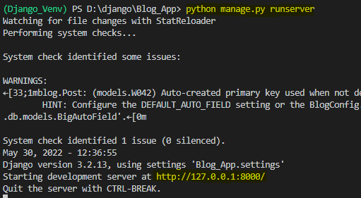

Copy the link and paste it to the Web Browser to run the Blog_App.

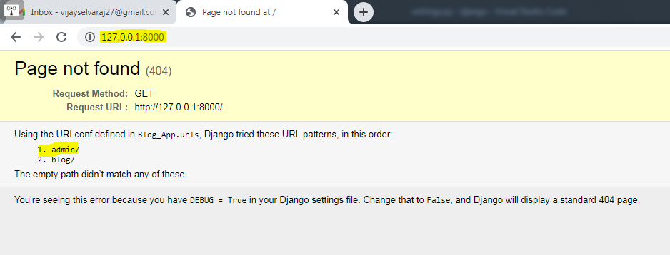

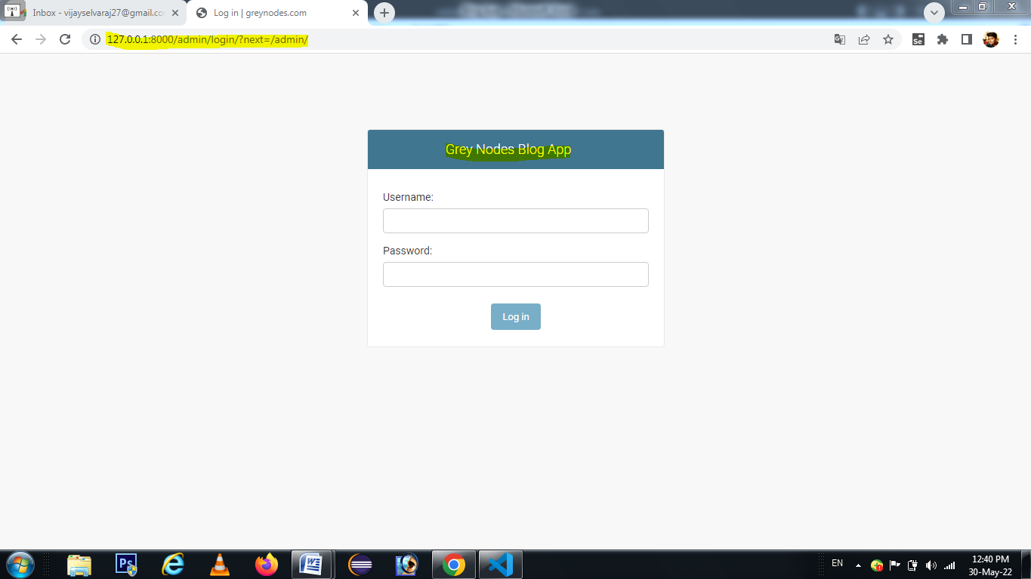

Here we achieved Blog_App admin app successfully.

Manange.py( for this only migrate and migrations)

from django.db import models

class Requirments(models.Model):

# id = models.IntegerField(primary_key=True)

S_NO = models.IntegerField()

Date = models.DateField()

Name = models.CharField(max_length=60)

GenderOptions = (

('M', 'Male'),

('F', 'Female'),

)

Gender = models.CharField(max_length=1, choices=GenderOptions)

Location = models.TextField()

ApplyPost = models.CharField(max_length=255)

Qualification = models.TextField()

MobileNumber = models.CharField(max_length=13)

Gmail = models.CharField(max_length=255, unique=True, blank=True, null=True)

Refer =models.CharField(max_length=150)

Experience = models.TextField()

CTC = models.CharField(max_length=255)

ECTC = models.CharField(max_length=255)

NoticePeriod = models.CharField(max_length=255)

HRRound = models.CharField(max_length=255)

FirstRound = models.CharField(max_length=255)

SecondRound = models.CharField(max_length=255)

ThirdRound = models.CharField(max_length=255)

FourthRound = models.CharField(max_length=255)

FINAL =models.CharField(max_length=255)

STATUS = models.CharField(max_length=255)

REMARKS = models.CharField(max_length=255)

ModeofInterivew= models.CharField(max_length=255)

def __str__(self):

return self.Name+self.MobileNumber

Save - ORM Method

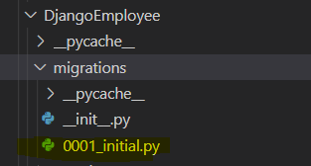

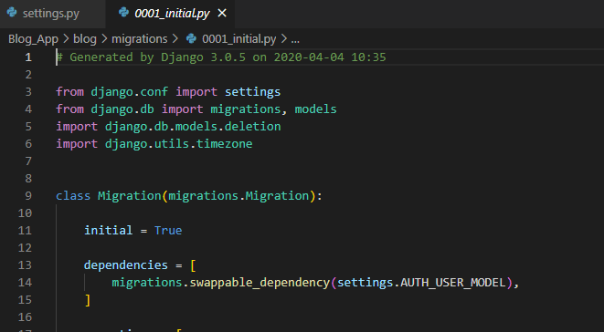

Sample Screenshot of Blog_App:

Home Page

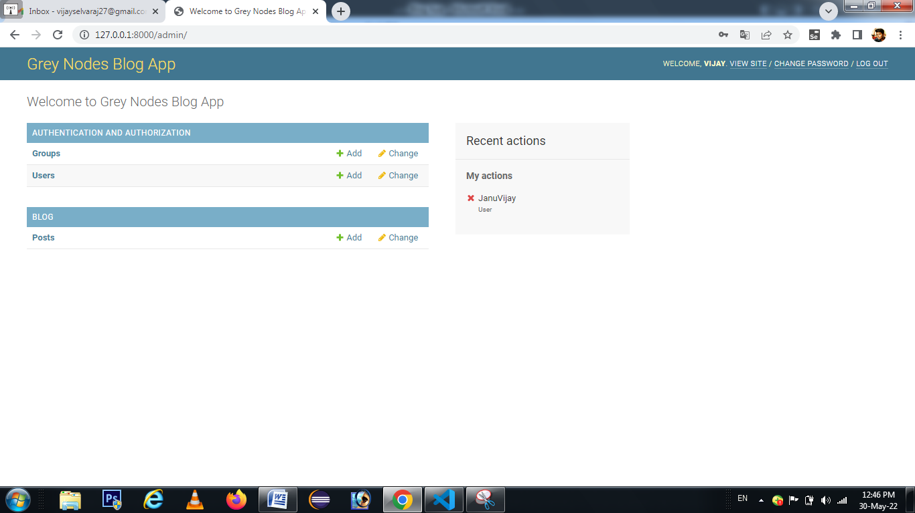

User Page:

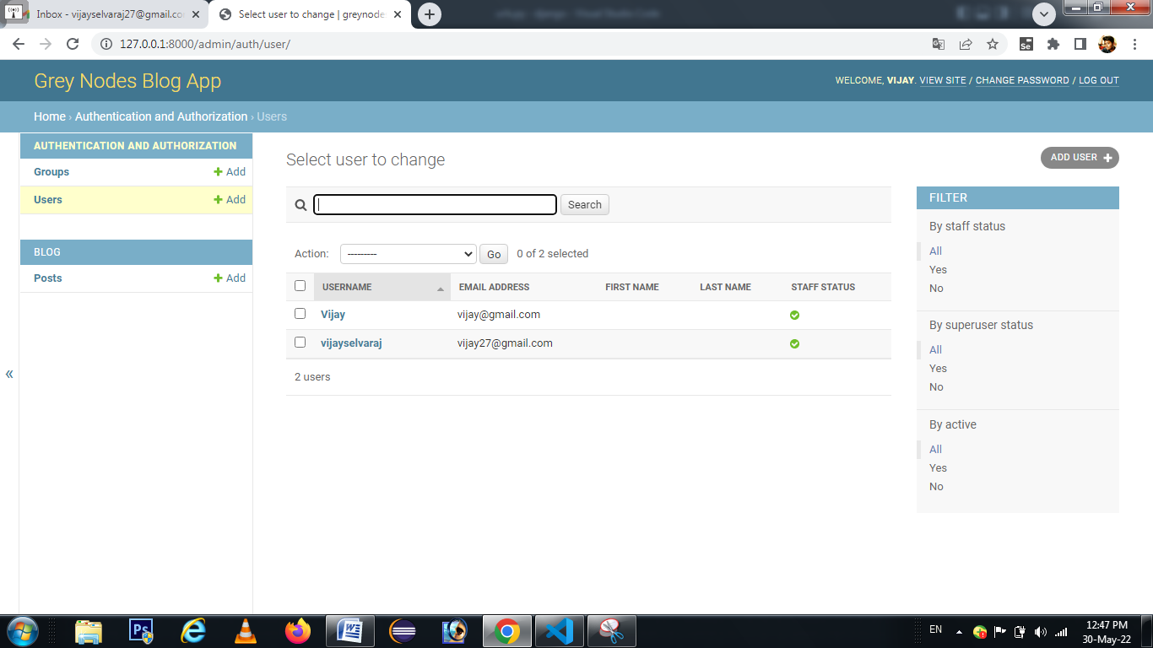

Blog Post Creation Page:

